SIMATS ENGINEERING
CO2_ASSESSMENT TOOL 1: Analytical Problem Solving

COURSE NAME: | Cloud Computing and Big Data Analytics | COURSE CODE: | CSA1522
Name | DIVYASREE.M
Register Number | 192524098

COURSE OUTCOME COVERED
CO2: Analyze virtualization architectures to identify performance and security issues in cloud computing environments. (BL3)
Dave's Taxonomy: Manipulation (Level 2)  Question Count: 5 | Total Marks: 50

Code of Conduct
I DIVYASREE.M/192524098 (Name / Reg No) certify that this submission is my original work and that I have adhered to the guidelines specified for this assessment.
I understand that any violation of academic integrity rules will result in disciplinary action.
Signature of the student: ____________________
Assessment Tasks
Analytical Problem Solving
- Compare Type-1 and Type-2 hypervisors for a cloud datacenter hosting mission-critical applications. Analyze performance, security, and manageability, then justify the better choice.
- A cloud provider must isolate workloads belonging to finance, healthcare, and student portals on the same hardware. Analyze how virtualization architecture supports isolation and identify two major attack surfaces.
- Study the following VM host utilization snapshot and recommend corrective actions: CPU 92%, memory 88%, storage I/O latency 35 ms, average VM boot time 170 s. Explain the likely bottlenecks.
- Analyze how Software Defined Datacenter architecture improves agility compared with a traditional datacenter. Support your answer with compute, storage, and network virtualization considerations.
- A multi-cloud federation project fails due to identity mismatches between providers. Analyze the issue and propose a secure identity and privacy design using federation concepts.

Analytical Problem Solving Rubric

Criteria | Weightage | Level 4 - Exemplary | Level 3 – Proficient | Level 2 - Developing | Level 1 - Beginning
Problem Interpretation | 20% | Interprets all technical requirements accurately | Interprets most requirements correctly | Partial interpretation | Misinterprets the problem
Analytical Reasoning | 25% | Strong reasoning with clear cause-effect analysis | Good reasoning with minor gaps | Basic analysis only | Weak or no analysis
Method Selection | 20% | Chooses highly appropriate virtualization and security concepts | Chooses mostly suitable concepts | Partially suitable concepts | Inappropriate approach
Solution Quality | 20% | Provides feasible and technically sound solution | Reasonable solution with minor issues | Basic solution with limitations | Unclear or invalid solution
Presentation of Analysis | 15% | Well-structured and technically precise | Generally clear | Somewhat unclear | Difficult to follow

Total Marks Awarded:

1.Compare Type-1 and Type-2 hypervisors for a cloud datacenter hosting mission-critical applications. Analyze performance, security, and manageability, then justify the better choice.
Problem Analysis
A cloud datacenter hosting mission-critical applications requires high performance, strong security, reliability, and centralized management.
TYPE-1 :BARE METAL HYPERVISOR:
- Runs directly on hardware.
- Smaller attack surface.
- It has high scalability.
- The resource management is efficient.
- Ex:VMware ESXi,Xen.
TYPE-2:HOSTED HYPERVISOR:
- Runs on top of a host OS
- Additional overhead from host OS
- Vulnerable through host OS
- Scalability is moderate
- The resource management is less efficient than type -1
- Ex:VMware Workstation,Virtual Box
Analytical Reasoning
- Since Type-1 hypervisors run directly on hardware, they eliminate the extra software layer introduced by a host operating system. As a result, CPU scheduling, memory access, and I/O operations are faster, which improves application response time and overall performance.
- Because Type-2 hypervisors depend on a host operating system, every VM request must pass through an additional software layer. This increases resource consumption and may introduce performance bottlenecks making them less suitable for mission-critical workloads.
- When it comes to security Type-1 or Bare metal hypervisor is stronger as attackers must compromise the hypervisor itself rather than both the host OS and hypervisor.
- The administrators in data centers can manage hundreds of virtual machines efficiently using centralized orchestration tools.
Conclusion and Justification:
In conclusion,The type-1 hypervisor is a better and a more reliable choice for mission-critical cloud environments as it has:
- Higher performance through direct hardware access.
- Better security due to a reduced attack surface.
- Improved scalability and availability.
- Easier enterprise-level management.
Therefore,the Bare Metal Hypervisors are preferred in production cloud data centers.

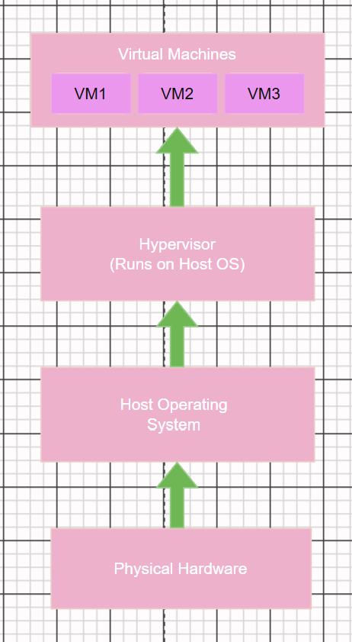
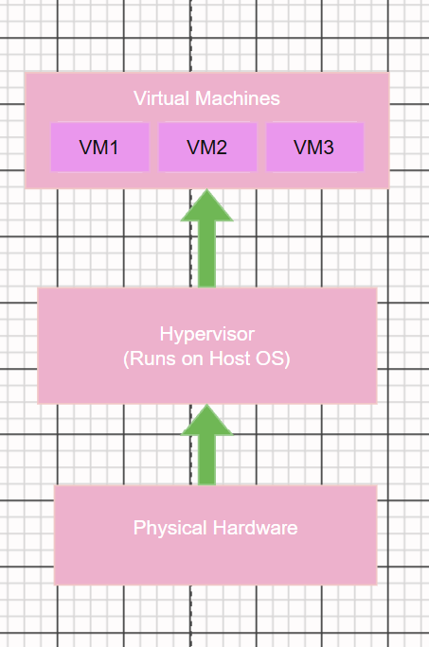

Bare-Metal Hypervisor Hosted Hypervisor

2.A cloud provider must isolate workloads belonging to finance, healthcare, and student portals on the same hardware. Analyze how virtualization architecture supports isolation and identify two major attack surfaces.
Problem Analysis
Multiple departments share the same physical infrastructure while requiring strict separation of workloads and sensitive data.
How Virtualization Supports Isolation
Compute Isolation
- Independent operating systems
- Separate memory spaces
Network Isolation
- Finance traffic remains isolated
- Healthcare systems comply with privacy requirements
Storage Isolation
Virtual disks and storage policies prevent unauthorized access between departments.
Analytical Reasoning
Virtualization introduces logical boundaries that prevent one workload from directly accessing another workload's resources even when hosted on the same hardware.
Major Attack Surfaces
1. Hypervisor Attacks
An attacker exploiting a hypervisor vulnerability could potentially gain access to multiple VMs.This can lead to:
- Cross-VM compromise
- Data leakage
- Privilege escalation
2. VM Escape Attacks
A malicious process inside a VM attempts to break out and access the host or neighboring VMs.This can lead to
- Unauthorized access
- Service disruption
- Sensitive information exposure
Conclusion
Through compute,network and storage separation the virtualization provides a strong workload isolation .However the hypervisor compromise and VM escape remain critical attack surfaces and it should be taken care of using layered security controls.
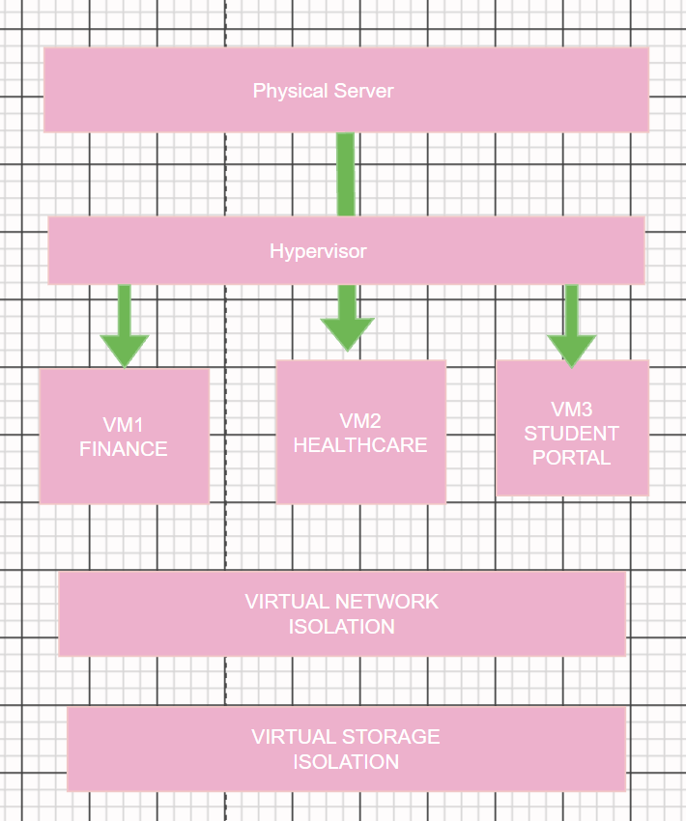

WORKLOAD ISOLATION USING VIRTUALIZATION

3.Study the following VM host utilization snapshot and recommend corrective actions: CPU 92%, memory 88%, storage I/O latency 35 ms, average VM boot time 170 s. Explain the likely bottlenecks.
Given Data
CPU-92%
Memory-88%
Storage I/O-35ms
Avg VM Boot time-170s
Problem Statement:
The host exhibits high resource utilization and slow VM startup times, indicating performance degradation.
Analytical Reasoning
CPU Bottleneck
CPU utilization at 92% indicates:
- Excessive VM consolidation
- CPU contention among VMs
- Increased scheduling delays
Effect:
Applications experience slower response times.
Memory Bottleneck
Memory utilization at 88% suggests:
- Memory pressure
- Potential swapping
- Reduced VM performance
Effect:
Additional disk operations increase latency.
Storage Bottleneck
Storage latency of 35 ms is significantly high.
Possible Causes:
- Disk contention
- Insufficient IOPS
Effect:
Slow VM startup and application delays.
Corrective Actions
High CPU- Migrate the VM’s to another host
High Memory-Increase RAM or rebalance the workloads.
Storage Latency-Upgrade to SSD/NVMe storage
Slow VM startup use VM templates and optimize storage
Conclusion
The storage I/O latency is the primary bottleneck.it is amplified by CPU and memory pressure Resource balancing, storage upgrades, and workload migration will improve overall performance.
4. Analyze how Software Defined Datacenter architecture improves agility compared with a traditional datacenter. Support your answer with compute, storage, and network virtualization considerations.
Problem Statement
Traditional datacenters depend heavily on manual hardware provisioning, whereas SDDC virtualizes and automates infrastructure.
Traditional Datacenter Limitations
- Manual configuration
- Slow deployment
- Hardware dependency
- Limited scalability
SDDC-(Software Defined Datacenter) Architecture Components
Compute Virtualization
Physical servers are abstracted into virtual machines.
Benefit:
New workloads can be deployed within minutes.
Storage Virtualization
Physical storage devices are pooled into logical storage resources.
Benefit:
Dynamic allocation of storage based on demand.
Network Virtualization
Software-defined networking creates programmable virtual networks.
Benefit:
Rapid network provisioning and policy enforcement.
Analytical Reasoning
Compared to a traditional datacenter, a Software Defined Datacenter (SDDC) significantly improves agility by reducing provisioning time from days or weeks to just minutes, enabling automated scalability instead of manual expansion, increasing resource utilization through dynamic allocation of resources, and providing greater flexibility to adapt quickly to changing business requirements.

Impact on Agility
- Faster service deployment.
- Automated resource allocation.
- Better workload mobility.
- Reduced operational costs.
- Improved disaster recovery capabilities.
Conclusion
SDDC significantly improves agility by virtualizing compute, storage, and networking resources, enabling automated provisioning, rapid scaling, and efficient infrastructure management.
5.A multi-cloud federation project fails due to identity mismatches between providers. Analyze the issue and propose a secure identity and privacy design using federation concepts.
Problem Statement:
A multi-cloud federation project fails because different cloud providers use separate identity systems, authentication methods, and user attributes.
Analysis
Identity Inconsistency
Different providers may:
- Use different user identifiers
- Maintain separate role definitions
- Support different authentication protocols
Consequences
- Authentication failures
- Authorization errors
- Duplicate user accounts
Proposed Secure Identity Federation Design
Central Identity Provider (IdP)
Use a trusted Identity Provider to authenticate users once.
Examples:
- Microsoft Entra ID
Federated Authentication
Implement:
- SAML 2.0
- OpenID Connect (OIDC)
This enables Single Sign-On (SSO) across providers.
Role-Based Access Control (RBAC)
Standardize roles across clouds:
- Finance Admin
- Healthcare User
- Student Portal User
Privacy Protection
Apply:
- Data minimization
- Attribute-based access control
- Encryption in transit and at rest
- Consent management
Secure Architecture Flow
- User authenticates with Identity Provider.
- Identity Provider issues security token.
- Cloud providers trust the token.
- Access rights are mapped through RBAC policies.
- Sensitive attributes are shared only when required.
Conclusion
The failure occurs due to inconsistent identity management across cloud providers. A federation architecture using a centralized Identity Provider, SAML/OIDC protocols, RBAC, and privacy-preserving controls provides secure, scalable, and interoperable multi-cloud access.

